**Software Requirements Specification (SRS)**

**Book Store**

1. **Introduction**

The Software Requirements Specification (srs) is designed to document and describe the agreement between the customer and the developer regarding the specification of the software product requested. Its primary purpose is to provide a clear and descriptive “statement of user requirements” that can be used as a reference in further development of the software system.

* 1. **Purpose**

The purpose of this document is to give a detailed description of the requirements for the “Book Store” software.

* 1. **Scope**

The "Book Store" is a windows application that helps employees in book stores manage the stock and the types of the books in store.

The application can add new items, update an existing item, sell item to customers and show purchases history.

The users of the application are the store workers, an admin worker have permissions to all the operations of the software and the employee have only access to sell items to customers.

* 1. **Document conventions**

This document uses the following conventions.

|  |  |
| --- | --- |
| Term | Definition |
| User | Someone who interacts with the Book Store application |
| Admin | A user that have permissions for all the software operations |
| Employee | A user that can only use sell operation |
| DB | Database |
| Erd | Entity relationship diagram |

* 1. **References**

Sela preparation course

1. **Overall Description**

This section will give an overview of the whole system. The system will be explained in its context to show how to use the system using screenshots.

* 1. **Login**

When you start the software a login window will appear, after we fill the email and password and press login, the software will search for the user in the DB.

If the user does not exist in the DB a popup will appear, else we move to 2.3.

If you don’t have a user and want to sign up click Register button

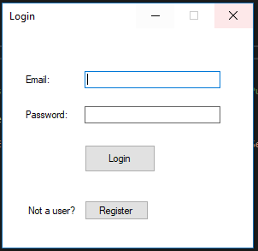

* 1. **Register**

Add new user to the db

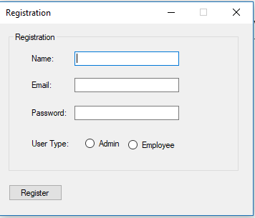

* 1. **Store**

Shows the items separated by types, and the operations that can be done. When logging in with employee user the buttons "add item", "update" and "purchase history" will be disabled.

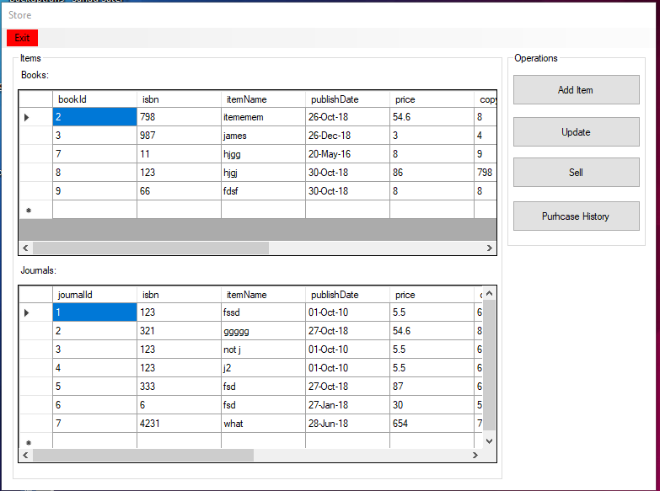

* 1. **Add item**

By clicking on type radio button all the fields that connected to the clicked type will be able to be filled

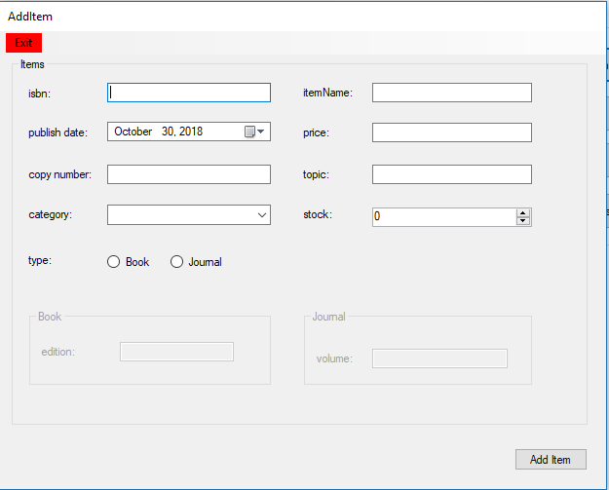

* 1. **Update**

If you want to update an item click on the row of the item in store window (2.3.) and after you change the values click update

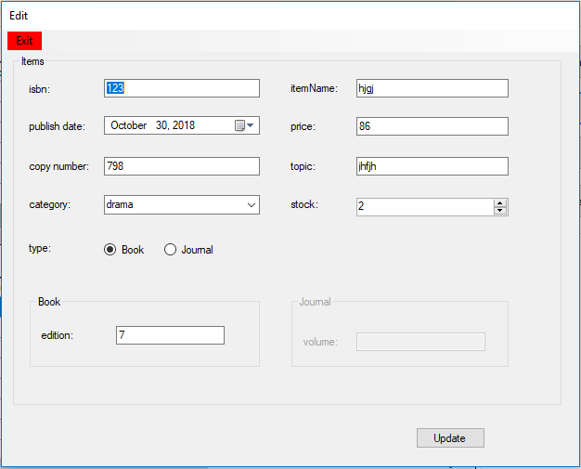

* 1. **Purchase**

Click on item from the table in store window (2.3.) and click sell. In Purchase window fill the customer name that will buy the item and the quantity.

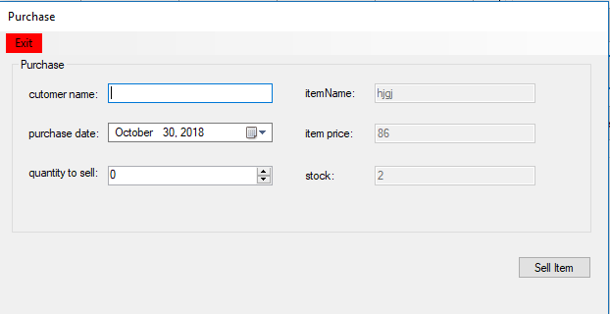

* 1. **Purchases History**

Purchases history will show you all the purchases that have been made in the software.

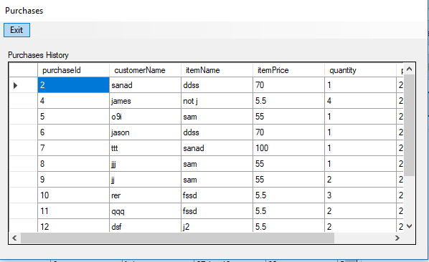

* 1. Design and Implementation

1. **Design and Implementation**
   1. UML and erd
   2. Model class library
   3. Implement the database tables
   4. Gui and controller class library
   5. srs
2. **External Interface Requirements**
   1. **User Interfaces**

* Front end – Microsoft winforms
* Back end - ssms
  1. **Hardware interfaces**
* windows
  1. **Software interfaces**
* Operating system – windows
* Database – Microsoft SQL Server Management Studio
* Visual studio – class library and winforms projects in c#